Technologies that should be considered for future education:
- Gesture Recognition Technologies:
  - Gesture recognition is a topic in computer science and language technology with the goal of interpreting human gestures via mathematical algorithms. Gestures can originate from any bodily motion or state but commonly originate from the face or hand. Current focuses in the field include emotion recognition from the face and hand gesture recognition. Many approaches have been made using cameras and computer vision algorithms to interpret sign language. However, the identification and recognition of posture, gait, proxemics, and human behaviors is also the subject of gesture recognition techniques.^{[1]}
  - Gesture recognition can be seen as a way for computers to begin to understand human body language, thus building a richer bridge between machines and humans than primitive text user interfaces or even GUIs (graphical user interfaces), which still limit the majority of input to keyboard and mouse.
  - Gesture recognition enables humans to interface with the machine (HMI) and interact naturally without any mechanical devices. Using the concept of gesture recognition, it is possible to point a finger at the computer screen so that the cursor will move accordingly. This could potentially make conventional input devices such as mouse, keyboards and even touch-screens redundant.
(http://en.wikipedia.org/wiki/Gesture_recognition, April 10, 2011)
Watch Video (http://www.eyesight-tech.com/technology/)
Note to self: made a page with video called gesturerecognition.fla but didn’t get it to play. Need to redo using flash software to create the page.
- Telepresence
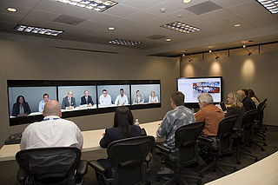
  - Telepresence refers to a set of technologies which allow a person to feel as if they were present, to give the appearance that they were present, or to have an effect, via telerobotics, at a place other than their true location.
  - Telepresence requires that the users' senses be provided with such stimuli as to give the feeling of being in that other location. Additionally, users may be given the ability to affect the remote location. In this case, the user's position, movements, actions, voice, etc. may be sensed, transmitted and duplicated in the remote location to bring about this effect. Therefore information may be traveling in both directions between the user and the remote location.
  - A popular application is found in telepresence videoconferencing, a higher level of videotelephony which deploys greater technical sophistication and improved fidelity of both video and audio than in traditional videoconferencing.
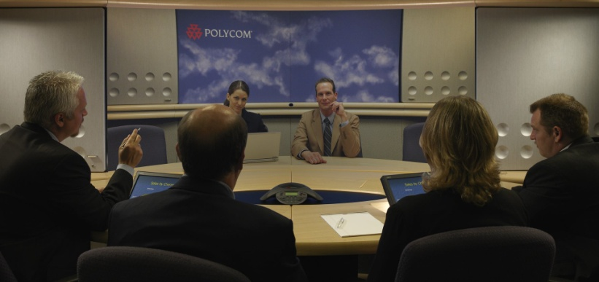
  - The term telepresence was coined in a 1980 article by Marvin Minsky, who outlined his vision for an adapted version of the older concept of teleoperation that focused on giving the remote participation a feeling of actually being present.^{[1]}
  - The first commercially successful telepresence company, Teleport (which was later renamed TeleSuite), was founded in 1993 by David Allen and Harold Williams.^{[2]} Before TeleSuite, they ran a resort business from which the original concept emerged, because they often found businesspeople would have to cut their stays short to participate in important meetings. Their idea was to develop a technology that would allow businesspeople to attend their meetings without leaving the resorts so that they could lengthen their hotel stays.
(http://en.wikipedia.org/wiki/Telepresence, April 10, 2011)

