1. | Use the following account balances from the adjusted trial balance of ABC Consulting  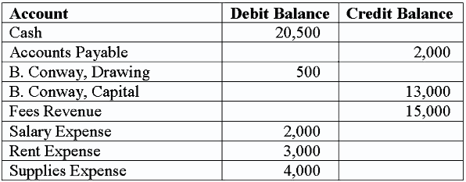  Select the correct closing entry that ABC Consulting would make to close their revenue account(s) at the end of the accounting period.  A. debit Fees Revenue and credit Cash for $15,000.  B. debit Income Summary and credit Fees Revenue for $15,000.  C. debit Fees Revenue and credit B. Conway, Capital for $15,000.  D. debit Fees Revenue and credit Income Summary for $15,000.

2. | Use the following account balances from the adjusted trial balance of ABC Consulting  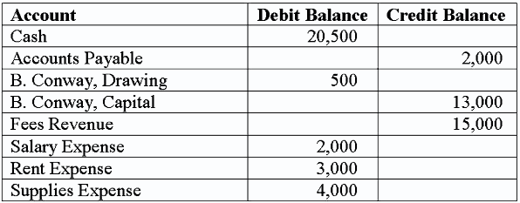  Select the correct closing entry that ABC Consulting would make to close their expense account(s) at the end of the accounting period.  A. debit Salary Expense $2,000; debit Rent Expense $3,000; debit Supplies Expense $4,000 and credit Income Summary $9,000.  B. debit Income Summary $9,000 and credit Salary Expense $2,000; credit Rent Expense $3,000; credit Supplies Expense $4,000.  C. debit Income Summary $9,000 and credit B. Conway, Capital for $9,000.  D. debit B. Conway, Capital $9,000 and credit Salary Expense $2,000; credit Rent Expense $3,000; credit Supplies Expense $4,000.

3. | An adjusted trial balance:  A. Is a list of all accounts and their balances after adjusting entries.  B. Is a list of all accounts and their balances before adjusting entries.  C. Is a list of all accounts and their balances after closing entries.  D. Is a trial balance adjusted for cash-basis accounting.

