Process Costing Quiz
Student: ___________________________________________________________________________
1. | The Assembly Department started the month with 59,000 units in its beginning work in process inventory. An additional 274,000 units were transferred in from the prior department during the month to begin processing in the Assembly Department. There were 21,000 units in the ending work in process inventory of the Assembly Department.  How many units were transferred to the next processing department during the month?  A. 333,000  B. 236,000  C. 354,000  D. 312,000

2. | Dewey Company uses the weighted-average method in its process costing system. The first processing department, the Welding Department, started the month with 15,000 units in its beginning work in process inventory that were 20% complete with respect to conversion costs. The conversion cost in this beginning work in process inventory was $19,200. An additional 86,000 units were started into production during the month. There were 13,000 units in the ending work in process inventory of the Welding Department that were 60% complete with respect to conversion costs. A total of $575,360 in conversion costs were incurred in the department during the month. The cost per equivalent unit for conversion costs is closest to:  A. $5.812  B. $6.206  C. $6.400  D. $6.690

3. | Process costing would be appropriate for each of the following except:  A. custom furniture manufacturing.  B. oil refining.  C. grain milling.  D. newsprint production.

4. | The following journal entry would be made in a processing costing system when units that have been completed in the final processing department are transferred to the finished goods warehouse:  True False

5. | In a process costing system, overhead is allocated to departments before being applied to units of product.  True False

6. | The "costs accounted for" portion of the cost reconciliation report includes the cost of ending work in process inventory and the cost of units transferred out.  True False

ProcessCosting Key
1. | The Assembly Department started the month with 59,000 units in its beginning work in process inventory. An additional 274,000 units were transferred in from the prior department during the month to begin processing in the Assembly Department. There were 21,000 units in the ending work in process inventory of the Assembly Department.  How many units were transferred to the next processing department during the month?  A. 333,000  B. 236,000  C. 354,000  D. 312,000  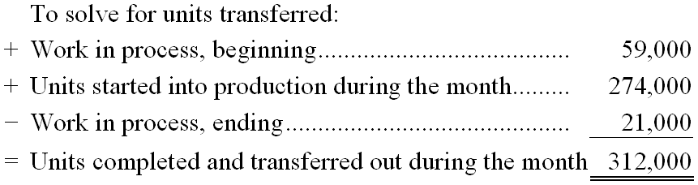

AACSB: Analytic
AICPA BB: Critical Thinking
AICPA FN: Measurement
Garrison - Chapter 004 #11
Learning Objective: 1
Level: Easy

2. | Dewey Company uses the weighted-average method in its process costing system. The first processing department, the Welding Department, started the month with 15,000 units in its beginning work in process inventory that were 20% complete with respect to conversion costs. The conversion cost in this beginning work in process inventory was $19,200. An additional 86,000 units were started into production during the month. There were 13,000 units in the ending work in process inventory of the Welding Department that were 60% complete with respect to conversion costs. A total of $575,360 in conversion costs were incurred in the department during the month.  The cost per equivalent unit for conversion costs is closest to:  A. $5.812  B. $6.206  C. $6.400  D. $6.690  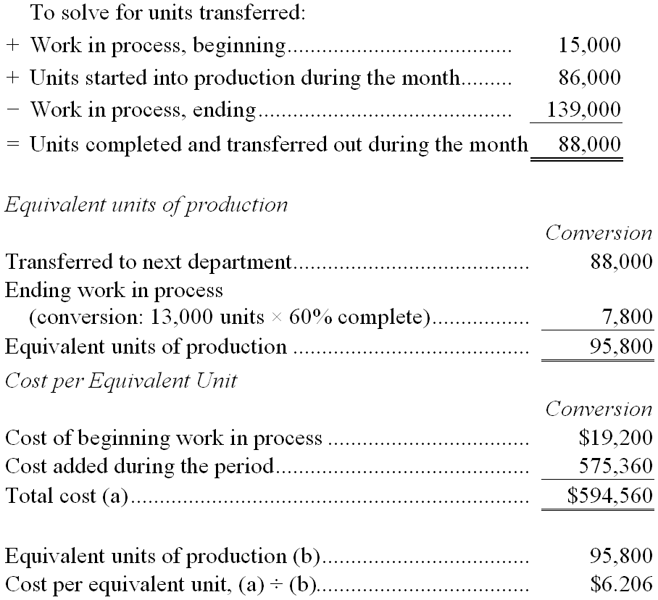

AACSB: Analytic
AICPA BB: Critical Thinking
AICPA FN: Measurement
Garrison - Chapter 004 #13
Learning Objective: 2
Learning Objective: 3
Level: Medium

3. | Process costing would be appropriate for each of the following except:  A. custom furniture manufacturing.  B. oil refining.  C. grain milling.  D. newsprint production.

AACSB: Reflective Thinking
AICPA BB: Industry
AICPA FN: Measurement
Garrison - Chapter 004 #7
Learning Objective: 1
Level: Easy

4. | The following journal entry would be made in a processing costing system when units that have been completed in the final processing department are transferred to the finished goods warehouse:  FALSE

AACSB: Reflective Thinking
AICPA BB: Critical Thinking
AICPA FN: Measurement
Garrison - Chapter 004 #1
Learning Objective: 1
Level: Easy

5. | In a process costing system, overhead is allocated to departments before being applied to units of product.  TRUE

AACSB: Reflective Thinking
AICPA BB: Critical Thinking
AICPA FN: Measurement
Garrison - Chapter 004 #2
Learning Objective: 1
Level: Easy

6. | The "costs accounted for" portion of the cost reconciliation report includes the cost of ending work in process inventory and the cost of units transferred out.  TRUE

AACSB: Reflective Thinking
AICPA BB: Critical Thinking
AICPA FN: Measurement
Garrison - Chapter 004 #6
Learning Objective: 5
Level: Medium

ProcessCosting Summary
Category | # of Questions
AACSB: Analytic | 2
AACSB: Reflective Thinking | 4
AICPA BB: Critical Thinking | 5
AICPA BB: Industry | 1
AICPA FN: Measurement | 6
Garrison - Chapter 004 | 6
Learning Objective: 1 | 4
Learning Objective: 2 | 1
Learning Objective: 3 | 1
Learning Objective: 5 | 1
Level: Easy | 4
Level: Medium | 2

